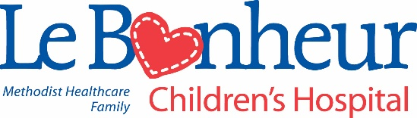

**Le Bonheur Children's Hospital**

**Child Life Practicum Program**

The child life practicum is a 4 week, minimum of 100 hours, dedicated time of observation and interaction within the health care setting where qualified students gain practical knowledge about the child life profession.

The primary goal of Le Bonheur’s child life practicum program is to provide an opportunity for students to evaluate the strengths and limitations of their current knowledge and to broaden their understanding of the child life profession.

Students will have the opportunity to become familiar with the various roles of a Certified Child Life Specialist including, but not limited to, medical play, normalization, procedural preparation and support. In addition, student will plan and supervise developmentally appropriate activities while working with individuals and groups. The practicum is designed to facilitate the student’s growth as a professional by allowing observation of the daily work of a Certified Child Life Specialist.

Child Life Services

Le Bonheur Children's Hospital

848 Adams Avenue

Memphis, TN 38103

(901) 287-6021

child.life@lebonheur.org

**QUALIFICATIONS OF APPLICANTS**

The practicum program is open to students who have completed their collegiate level sophomore year. Applicants must be majoring (or have a degree) in child development or a related field. Applicants must be located within our Southeastern Association of Child Life Professionals (SEACLP) region, which includes Tennessee, Alabama and Mississippi. We will consider both affiliated and unaffiliated students. At this time, we will not be considering applicants outside of our region.

**PRACTICUM SEMESTER**

Le Bonheur offers one practicum session during the summer. The session takes place during the month of June. Students must be able to attend mandatory orientation and complete their practicum hours within the month.

**APPLICATION DEADLINE**

Applications for the practicum program must be submitted online (<https://mlhforms.formstack.com/forms/child_life_practicum_application>) by

January 5th. Hand delivered or mailed applications will not be accepted. Notification of receipt will be emailed. INCOMPLETE OR LATE APPLICATIONS WILL NOT BE REVIEWED.

**APPLICATION**

Applications must be submitted online and consist of:

* Resume
  + Please be intentional to highlight relevant experiences
* Unofficial academic transcript(s)
* Attach a separate document briefly answering the following questions:
  + Describe your interest in the Child Life profession.
  + What are your strengths in working with children?
  + What aspects of working with children do you need to improve?
  + What do you hope to gain from the practicum experience?
  + Describe the ways in which the work of a child life specialist contributes to the health care experience of a child and his/her family.

**CANDIDATE NOTIFICATION**

The submission of an application does not guarantee placement. Acceptance is based on program capacity and qualifications of all applicants. The most qualified candidates will be notified by phone call to move forward with the interview process. Initial practicum offers will be made mid-February. Candidates who are not selected will receive notification by email.

Thank you for your interest in the Child Life Practicum at

Le Bonheur Children’s Hospital.